**EXPERIMENT NO:1**

**Use Figma to create an interactive diagram illustrating the components of a basic cellular system.**

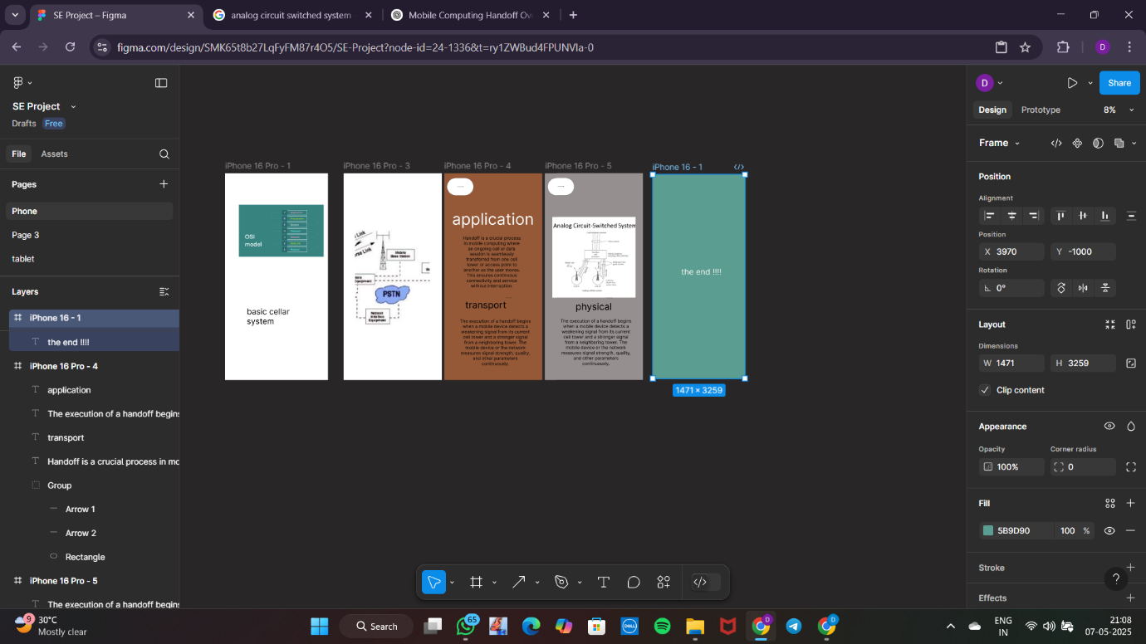

**192321135 VIGNESHWAR**